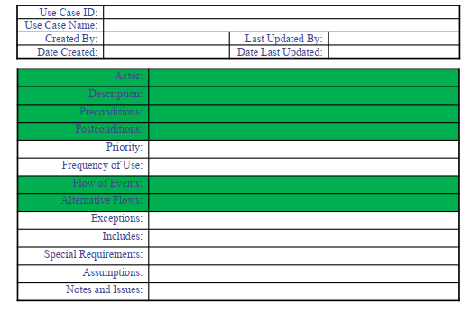

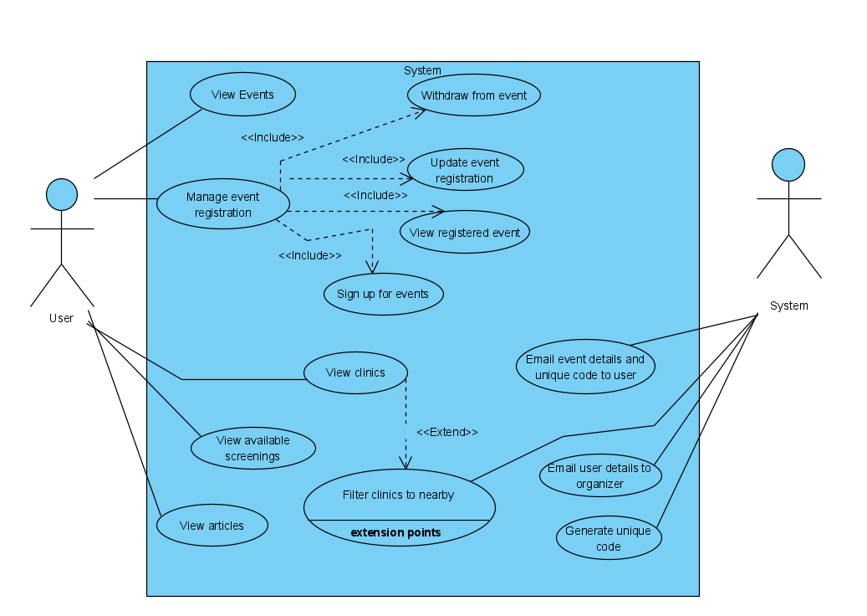

|  |  |
| --- | --- |
| **Use Case name** | **Generate Unique Code** |
| Use Case Description | The system generates a unique code and sends to the user |
| Actors | System |
| Pre-Condition | User signs up for an event |
| Post-Condition | The user receives a unique code |

|  |  |  |
| --- | --- | --- |
| **Main Scenarios** | **Serial No.** | **Steps** |
| Actors/Users | 1 | System generates unique code |
|  | 2 | System checks whether unique code already exists in the system |
|  | 3 | System stores a record of the unique code |
| **Alternate Scenarios** | **Serial No.** | **Steps** |
| AS-Step 3 | 1 | If code already exists, system will generate a new code |
|  | 2 | Repeat step 2 |

|  |  |
| --- | --- |
| **Use Case name** | **Manage Event Registration** |
| Use Case Description | Accessing the system to manage the users’ events |
| Actors | User |
| Pre-Condition | System must be connected to the network??? |
| Post-Condition | An email notification is sent to the user and event organizer after any successful alteration |

|  |  |  |
| --- | --- | --- |
| **Main Scenarios** | **Serial No.** | **Steps** |
| Actors/Users | 1 | System prompts the user to enter their unique code |
|  | 2 | After successful validation, the system prompts the user to select the desired activity ‘Withdraw’, ‘Update’, ‘View Registered’ or ‘Sign Up’. |
|  | 3 | If the user selects ‘Withdraw’, the use case ‘Withdraw from Events’ is used to withdraw from the event. |
|  | 4 | If the user selects ‘Update’, the use case ‘Update Events Registration’ is used to update an event the user is already registered to. |
|  | 5 | If the user selects ‘View Registered’, the use case ‘View Registered Events’ is used to view what event the user is registered at. |
|  | 6 | If the user selects ‘Sign Up’, the use case ‘Sign Up for Events’ is used to sign up for an event. |
| **Alternate Scenarios** | **Serial No.** | **Steps** |
| AS-Step 2 | 1 | If the unique code is invalid, the system displays the message “Invalid code! Please try again” for 2 seconds |
|  | 2 | System returns to Main Step 1 |

|  |  |
| --- | --- |
| **Use Case name** | **View Registered Event** |
| Use Case Description | System displays users’ registered events |
| Actors | Users |
| Pre-Condition | System validates users’ unique code |
| Post-Condition | System displays users’ registered events details on a web page?? |

|  |  |  |
| --- | --- | --- |
| **Main Scenarios** | **Serial No.** | **Steps** |
| Actors/Users | 1 | System gets users’ registered events and displays users’ registered on-going events |
|  |  |  |
| **Alternate Scenarios** | **Serial No.** | **Steps** |
| AS-Step 1 | 1 | If the user does not have any registered event, the system displays the message “You are currently not registered under any events.” |
|  | 2 | System returns to use case ‘Manage Event Registration’ step 2 |

|  |  |
| --- | --- |
| **Use Case name** | **Sign up for Events** |
| Use Case Description | System takes in user details which are then sent to the event organizer |
| Actors | User |
| Pre-Condition |  |
| Post-Condition | User successfully signs up for the event |

|  |  |  |
| --- | --- | --- |
| **Main Scenarios** | **Serial No.** | **Steps** |
| Actors/Users | 1 | System prompts the user of which event does he/she wants to sign up for |
|  | 2 | System checks whether the event registration period is still on-going |
|  | 3 | After confirmation, the system gets the registration details needed from the event organizer |
|  | 4 | The system then displays the registration details needed and prompts the user to fill in the information need |
|  | 5 | Once filled, the system checks if all required details are correctly filled |
|  | 6 | If true, the system then prompts the user to validate the details given |
|  | 7 | After confirmation, the system uses the use case ‘Email Users’ Details to Event Organizer’ to sign up the user to an event |
| **Alternate Scenarios** | **Serial No.** | **Steps** |
| AS-Step 2 | 1 | System displays the message “Unfortunately the registration for this event has already ended.” for 5 seconds |
|  | 2 | System then returns to Main Step 1 |
| AS-Step 6 | 1 | If the user either does not fill the required registration details or correctly fill the registration details, the system will display the message “Please fill in the appropriate registration details.” |
|  | 2 | System then returns to Main Step 4 with the user details already filled with what the user had previously written. Details that are needed to be filled or incorrectly filled are highlighted in red to alert the user of the changes he/she has to make |
| AS-Step 7 | 1 | If the user wants to edit the details, the system will return to Main Step 4 with the user details already filled with what the user had previously written |

|  |  |
| --- | --- |
| **Use Case name** | **Update Events Registration** |
| Use Case Description | User wants to update their details for the event registration |
| Actors | User |
| Pre-Condition | User is registered to an event |
| Post-Condition | User’s event registration details are updated |

|  |  |  |
| --- | --- | --- |
| **Main Scenarios** | **Serial No.** | **Steps** |
| Actors/Users | 1 | User enters email and unique code for a specific event |
|  | 2 | System verifies email and unique code |
|  | 3 | System retrieves user’s details for event registration |
|  | 4 | User updates details |
|  | 5 | System prompts the user to confirm details |
|  | 6 | User confirms update |
|  | 7 | System updates details |
|  | 8 | System sends an email to the organizer and user about the updated details |
|  | 9 | System displays a success message |
|  |  |  |
| **Alternate Scenarios** | **Serial No.** | **Steps** |
| AS-Step 6 | 1 | User cancel changes |
|  | 2 | System closes prompt |

|  |  |
| --- | --- |
| **Use Case name** | **Withdraw from Events** |
| Use Case Description | User withdraw from registered event |
| Actors | User |
| Pre-Condition | User must be registered to an event |
| Post-Condition | User successfully withdraws from the event |

|  |  |  |
| --- | --- | --- |
| **Main Scenarios** | **Serial No.** | **Steps** |
| Actors/Users | 1 | User enters email and unique code for a specific event |
|  | 2 | System verifies email and unique code |
|  | 3 | System retrieves event details |
|  | 4 | System prompts the user to confirm the withdrawal |
|  | 5 | User confirms withdrawal |
|  | 6 | System removes the user’s event registration |
|  | 7 | System displays a success message |
|  | 8 | System sends an email to the user about the withdrawal |
| **Alternate Scenarios** | **Serial No.** | **Steps** |
| AS-Step 5 | 1 | User does not confirm the withdrawal |
|  | 2 | System closes prompt |
|  |  |  |

|  |  |
| --- | --- |
| **Use Case name** | **Email Users’ Details to Event Organizer** |
| Use Case Description | System sends user’s details to event organizer upon sign up, update and withdrawal |
| Actors | System |
| Pre-Condition |  |
| Post-Condition |  |

|  |  |  |
| --- | --- | --- |
| **Main Scenarios** | **Serial No.** | **Steps** |
| Actors/Users | 1 |  |
|  |  |  |
| **Alternate Scenarios** | **Serial No.** | **Steps** |
| AS-Step | 1 |  |

|  |  |
| --- | --- |
| **Use Case name** | **View clinics** |
| Use Case Description | System display all available clinics |
| Actors | User |
| Pre-Condition | - |
| Post-Condition | System display all available clinics |

|  |  |  |
| --- | --- | --- |
| **Main Scenarios** | **Serial No.** | **Steps** |
| Actors/Users | 1 |  |
|  |  |  |
| **Alternate Scenarios** | **Serial No.** | **Steps** |
| AS-Step | 1 |  |